BASIC COMPONENT SPECIFICATIONS
5 liter fuel can 375 gram
Revisiedatum: 7 July 2016

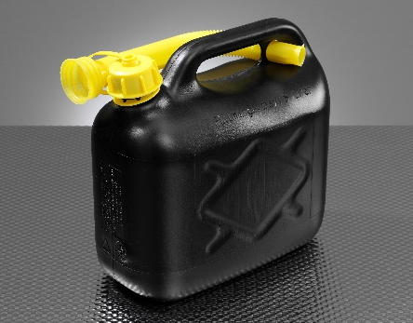
CONSTRUCTION
General description. | Rectangular extrusion blow-moulded UN approved free standing fuel can, supplied with a flexible spout
DIMENSIONS
 | Nominal | Minimum | Maximum
Capacity/L | 5,0 |  | 5,8
Length (mm) | 264 | 262 | 266
Width (mm) | 138 | 136 | 140
Height over grip (mm) | 250 | 248 | 252
Tare weight (gram) | 375 | 364 | 386
NECK FINISH
Neck type | Screw neck
Closure | 40 mm closure
Additional information | Sealing system | Sealing system
MATERIAL
Material | HDPE
Colour | On request
CERTIFICATION
UN Approved | UN Class Y1.0 / 200
Length
Heigth
Width

